Your company has recently decided to use Docker to run containers in production. They have built some Docker images to run their own proprietary software and need a place to store and manage these images. You have been asked to build a secure, private Docker registry for use by the company. In order to verify that everything works, you have also been asked to configure a Docker workstation server to push to and pull from the registry.

To complete this lab, ensure that the following requirements are met for the registry:

**1. A private Docker registry is running on the Docker registry server using version 2 of the registry image.**

**2. The container name for the registry should be registry.**

**3. The registry should always automatically restart if it stops or the Docker daemon or server restarts.**

**4. The registry should require authentication. Set up an initial account with the username docker and the password d0ck3rrU73z.**

**5. The registry should use TLS with a self-signed certificate.**

**6. The registry should listen on port 443.**

**Ans:**

Followed with the below link

<https://phoenixnap.com/kb/set-up-a-private-docker-registry>

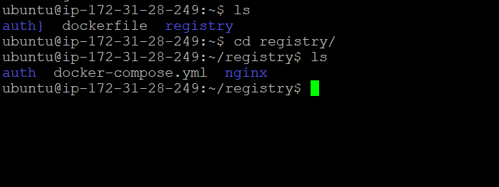

**Set up the Docker workstation server to meet the following requirements:**

**1. Docker is logged in to the private registry.**

**2. Docker is configured to accept the self-signed cert. Do not turn off certificate verification using the insecure-registries setting.**

**3. To confirm that everything is working, push a test image called ip-10-0-1-101:443/test-image:1 to the private registry. You can pull any image from Docker hub and tag it with ip-10-0-1-101:443/test-image:1 as a test.**

**4. Delete the test image locally and pull it from the registry.**

[NOTE: Write the series of commands to achieve above in this file below the question scenario with documentation]

Good luck!